2025 Annual Women's Health Summit

November 14, 2025

Purpose
A leading women's health summit in the Southern California region, focused on timely topics on women's health. Content is curated for clinician's, healthcare providers, academics, and health advocates. The 11th annual theme is menopause matters: a call to action. The summit includes a renowned keynote speaker, panel discussion, student-led poster presentation on various women's health topics, and a luncheon with a facilitated discussion on Conversations that Matter.

Target Audience
Specialties – Anesthesiology & Perioperative Care, Dermatology, Emergency Medicine, Family Medicine, Medicine, Neurological Surgery, Neurology, Obstetrics & Gynecology, Ophthalmology, Orthopaedic Surgery, Otolaryngology - Head & Neck Surgery, Pathology & Laboratory Medicine, Pediatrics, Physical Medicine & Rehabilitation, Plastic Surgery, Psychiatry & Human Behavior, Radiation Oncology, Radiological Sciences, Surgery, Urology, Other
Professions – Physician, Non-Physician, Nurse, Nurse Practitioner, Other, Physician Assistant, Registered Dietitian, Marriage and Family Therapist

Activity Objectives
1 Identify the public health significance of menopause, including its prevalence and impact on more than 50 million women in the U.S.
2 Analyze the associations between menopause and increased risks of heart disease, osteoporosis, and Alzheimer’s disease.
3 Evaluate the importance of evidence-based information from credible sources, such as the Menopause Society, in guiding patient care.
4 Assess the societal and economic impacts of menopause, both in the U.S. and globally.
5 Review current gaps in recognizing menopause medicine as a distinct field and its role in women’s health beyond reproductive years.
6 Compare FDA-approved treatments and services for menopause with non-regulated alternatives to support safe, effective patient care.
7 Discuss strategies to better communicate the societal value and contributions of women over 50 in the context of public health and medicine.

Accreditation Statement
This activity has been planned and implemented in accordance with the accreditation requirements and policies of the Accreditation Council for Continuing Medical Education (ACCME) through the joint providership of the University of California, Irvine School of Medicine and Joe C. Wen School of Population & Public Health. The University of California, Irvine School of Medicine is accredited by the ACCME to provide continuing medical education for physicians. to provide continuing medical education for physicians.

Designation Statement
The University of California, Irvine School of Medicine designates this Live Activity for a maximum of 2.25 AMA PRA Category 1 Credit(s)™. Physicians should claim only the credit commensurate with the extent of their participation in the activity.

California Assembly Bill 1195 and 241
This activity is in compliance with California Assembly Bill 1195 and 241, which require CME activities with patient care components to include curriculum in the subjects of cultural and linguistic competency & implicit bias. It is the intent of AB 1195 and AB 241 to encourage physicians and surgeons, CME providers in the State of California, and the Accreditation Council for Continuing Medical Education to meet the cultural and linguistic concerns of a diverse patient population and reduce health disparities through appropriate professional development. Please see the CME website, https://www.meded.uci.edu/CME/ for AB 1195 and AB 241 resources.





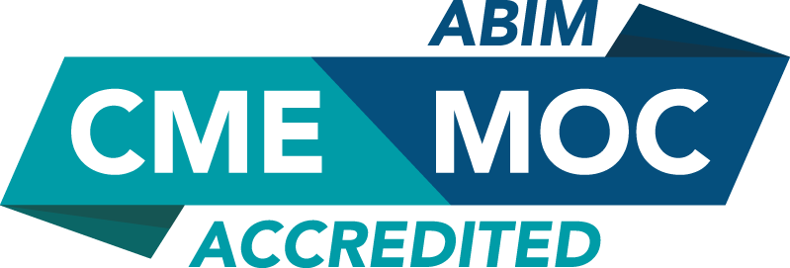

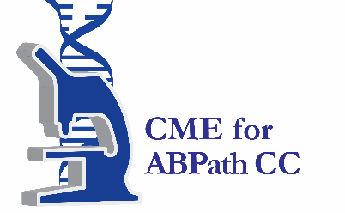

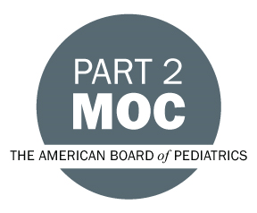

Faculty & Planner Disclosures
University of California, Irvine School of Medicine Continuing Medical Education adheres to the ACCME’s Standards for Integrity and Independence in Accredited Continuing Education. Any individuals in a position to control the content of a CE activity, including faculty, planners, reviewers, or others are required to disclose all relevant financial relationships with ineligible entities (commercial interests). All relevant conflicts of interest have been mitigated prior to the commencement of the activity.

Name of individual | Individual's role in activity | Nature of Relationship(s) / Name of Ineligible Company(s)
Nichole Quick, MD, MPH | Other Planning Committee Member | Nothing to disclose - 10/02/2025
Katelyn Ogawa, MPH | Activity Administrator | Nothing to disclose - 08/01/2025
Sautra Yazdanian, Other | Course Director | Nothing to disclose - 08/11/2025
Wen Shen, MD, MPH | Faculty | Stocks or stock options, excluding diversified mutual funds-AstraZeneca (Any division)|Stocks or stock options, excluding diversified mutual funds-Bristol-Myers Squibb Company|Stocks or stock options, excluding diversified mutual funds-Johnson & Johnson|Stocks or stock options, excluding diversified mutual funds-Merck (Any division) - 09/22/2025
Gigi Kroll, MD | Faculty | Nothing to disclose - 09/21/2025
Liz Powell, JD, Esq., MPH | Faculty | Nothing to disclose - 10/08/2025
Bernadette Boden-Albala, DrPH | Faculty | Nothing to disclose - 10/01/2025

Agenda
[INSERT AGENDA HERE MANUALLY]

Acknowledgement of Commercial Support
No commercial support has been received for this activity.

